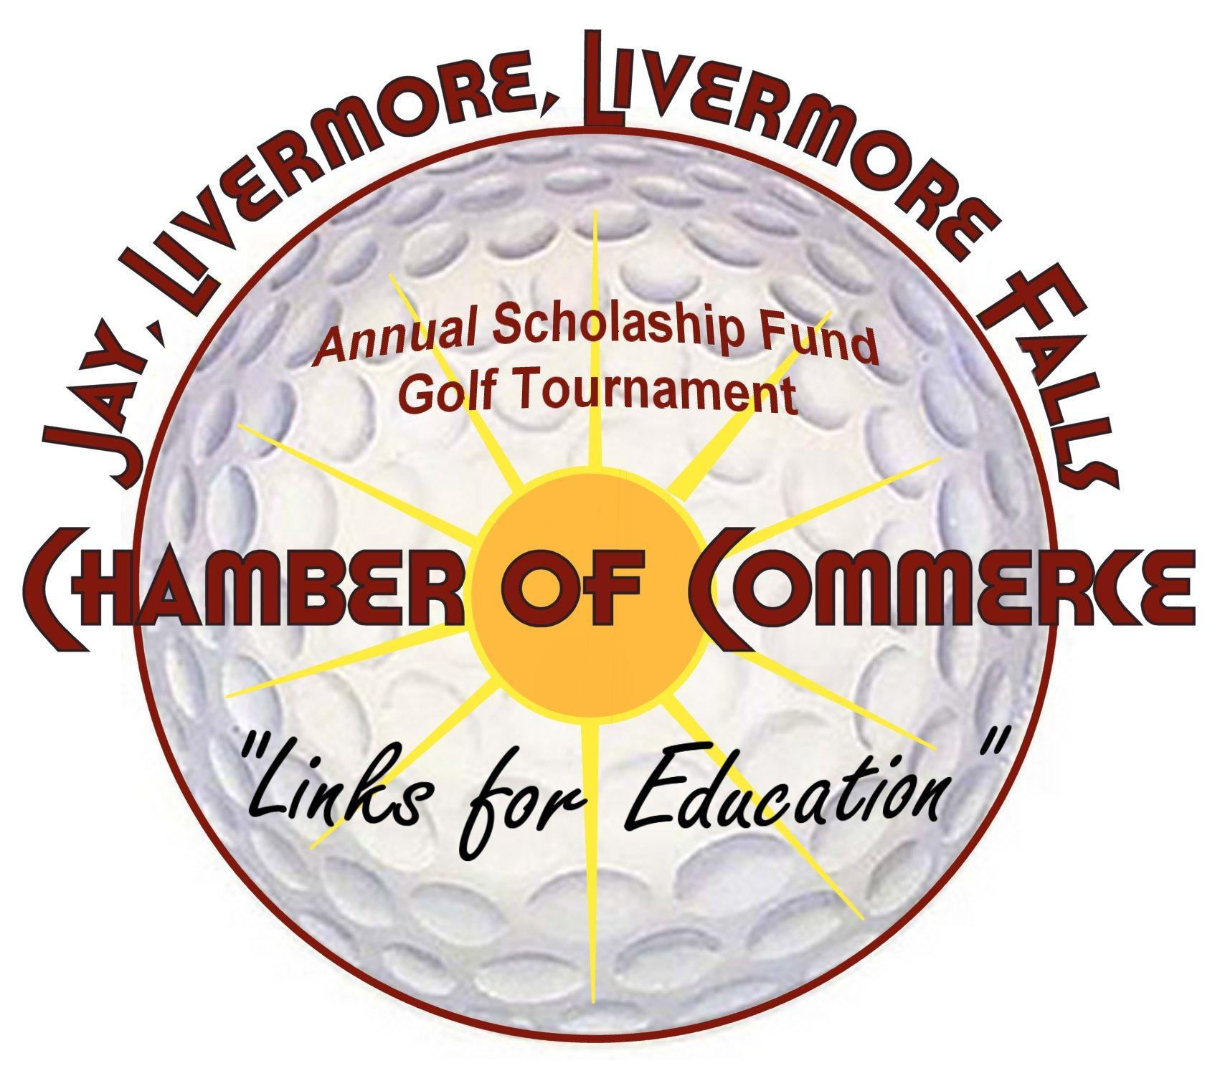

Saturday, June 17, 2017
(Rain or Shine)
Maple Lane Golf Course, 295 Maple Lane, Livermore
Please help us by sponsoring the 10th annual tournament, the banquet, a four-person team or any of the 18 holes. Other ways you could help would be donating gifts to be used for raffle prizes.
A committee member will be contacting you soon to discuss your participation and answer any questions you may have.
SPONSORSHIP LEVELS
____ Tournament Sponsor: (Only One) $500
Sponsor name included in tournament title, all advertising & golf course signage
____ Putting Contest Sponsor $300
____ Casino Hole Sponsor $300
____ Banquet Sponsors ( Sponsor name included in all advertising & banquet banner) $200 ea
____ Awards Gathering $200 ea
____ Golf Cart Sponsors (Sponsor names to appear on all carts) $200 ea
____ Longest Drive Sponsor $200 ea
____ Closest to Pin Sponsor $200 ea
____ Tee Box/ Greens Sponsors (Sponsor name displayed on tee box or green) $150 ea
____ TOTAL ______
Name of Business____________________________________________________________________
Address____________________________________________________________________________
Phone Number_______________________________________________________________________
Contact Person_______________________________________________________________________
E-mail Address______________________________________________________________________

Please return this sheet to: JLLF Chamber of Commerce, PO Box 458, Livermore Falls, Me 04254
Payment may be made by check or by PayPal. For PayPal, go to: www.jay-livermore-lf.org

