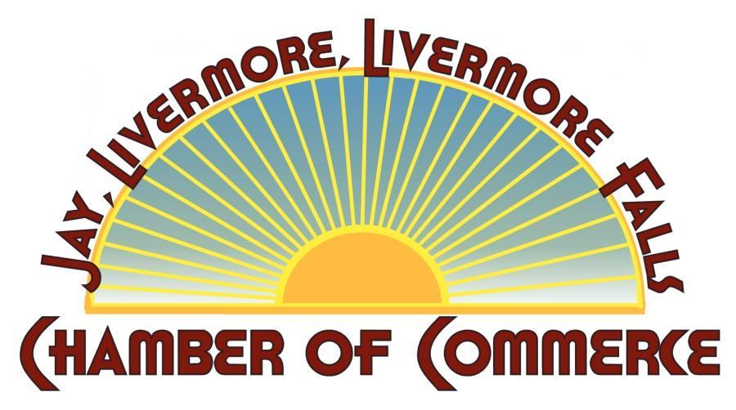
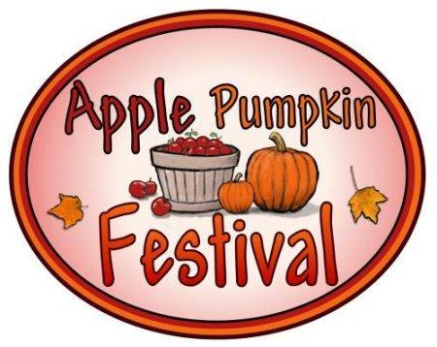
Jay-Livermore-Livermore Falls
Chamber of Commerce
Sponsorship Levels for the 2017
APPLE PUMPKIN FESTIVAL
E-mail: jllf@jay-livermore-lf.org
Website: www.applepumpkinfestival.org
Dear Friend:

As the time draws near for our Apple Pumpkin Festival on September 30, 2017, the Jay- Livermore-Livermore Falls Chamber of Commerce is asking the business community to help underwrite the costs of the event.

Last years’ festival drew to this area over 1,500 people, who also patronized and became aware of area merchants. With your supporting contribution, you will be included in the event promotions seen by thousands of people, which can include your name on the Chamber Website, company logo, print advertising, signage, posters and banners. We encourage you to email your logo to: jllf@jay-livermore-lf.org Your contribution is tax deductible.

Please join the JLLF Chamber of Commerce in making the 2017 Apple-Pumpkin Festival the best yet!

Thank you,
Executive Board Members

Bruce Adams, Murray Oil/BMA Holdings
Karin Ashmore, Inside Out Indoor Garden Supply & Ted Berry Company
Bob Berry, Main Land Development Consultants
Lisa Bilodeau, Androscoggin Bank
Sue Donovan, Donovan’s Auto Sales
Christine Fournier, Crayon Country Developmental Preschool/ Administrative Assistant
Diane Jackson, Franklin Savings Bank
Eileen Liddy, The Wilton Group
Paul Soucie, Retiree
Kim Turner, OFCU

Please check off a box below and enclose your check payable to JLLF Chamber of Commerce, P. O. Box 458, Livermore Falls, ME 04254. Questions should be directed to Sue Donovan @ 577-5991.
Sponsorships may also be paid using Pay Pal. The Chamber is now taking credit cards!! Please call the Chamber at 500-2464 to pay via credit card.
- Friends of Apple Pumpkin up to $149.00
- Business/ Corporate Sponsor $150.00-$499.99
- Event Underwriter $500.00-$999.00
- Major Underwriter $1000.00 and up

Business/Name:___________________________________________________________
Address:_________________________________________________________________
Town:_____________________________State:_______________Zip:_______________
Contact Person:___________________________________________________________
Phone:______________Fax:_______________E-Mail:____________________________

