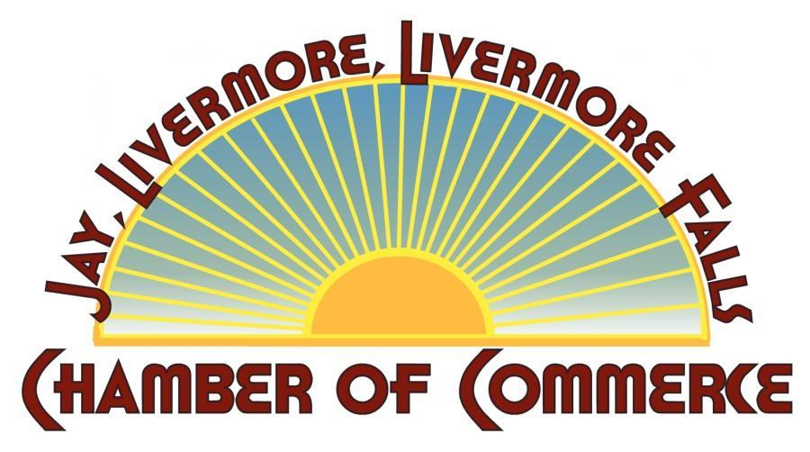
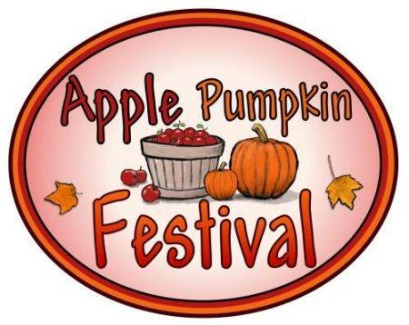
Jay-Livermore-Livermore Falls
Chamber of Commerce
Sponsorship Levels for the 2021
AAPPLE PUMPKIN FESTIVAL
E-mail: jllf@jay-livermore-lf.org
Website: www.jay-livermore-lf.org
Dear Friend:

As the time draws near for our Apple Pumpkin Festival on September 25, 2021, the Jay- Livermore-Livermore Falls Chamber of Commerce is asking the business community to help underwrite the costs of the event.

In the past, our festival drew to this area over 2,500 people, who also patronized and became aware of area merchants. With your supporting contribution, you will be included in the event promotions seen by thousands of people, which can include your name on the Chamber Website, company logo, print advertising, signage, posters and banners. We encourage you to email your logo to: jllf@jay-livermore-lf.org Your contribution is tax deductible.

Please join the JLLF Chamber of Commerce in making the 2021 Apple-Pumpkin Festival the best yet!

Thank you,
Executive Board Members
Karin Ashmore, Inside Out Indoor Garden Supply & Vortex Services
Bruce Adams, BMA Holdings
Brian McMullen, Pallet One
Kim Turner, Otis Federal CU
Melissa Gilbert, Berry Fruit Farm
Jody Robinson, Retiree
Amanda Lee, Franklin Savings Bank
Christine Fournier, Crayon Country Educational Childcare/ Administrator

Please check off a box below and enclose your check payable to JLLF Chamber of Commerce,
P. O. Box 458
Livermore Falls, ME 04254.

Sponsorships may also be paid using Pay Pal. Visit website or call the Chamber at 500-2464 to pay via credit card.
- Friends of Apple Pumpkin up to $149.00
- Business/ Corporate Sponsor $150.00-$499.99
- Event Underwriter $500.00-$999.00
- Major Underwriter $1000.00 and up
Business/Name:___________________________________________________________
Address:_________________________________________________________________
Town:_____________________________State:_______________Zip:_______________
Contact Person:___________________________________________________________
Phone:______________Fax:_______________E-Mail:____________________________

