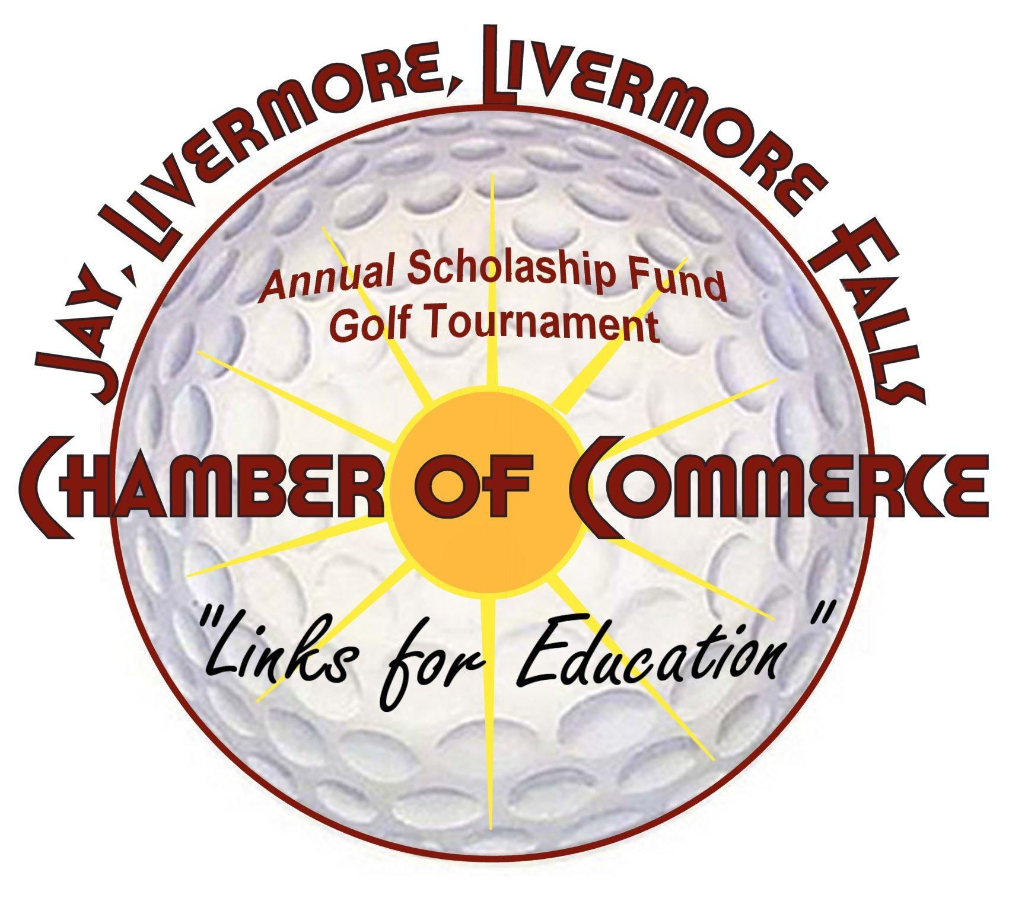

Saturday May 14, 2022 (Rain or Shine)
Turner Highlands
Please help us by sponsoring the 15th annual tournament, the banquet, a four-person team or any of the 18 holes. Other ways you could help would be donating gifts to be used for raffle prizes.
A committee member will be contacting you soon to discuss your participation and answer any questions you may have.
SPONSORSHIP LEVELS
____ Tournament Sponsor: (Only One) $1000
Sponsor name included in tournament title, all advertising & golf course signage & a team
____ Eagle Sponsor: $500
Signage on Drink Cart, advertising & golf course signage, 4 complementary strings & mulligans
____ Birdie Sponsor: $300
Signage at Contest Hole (Closest to Pin or Longest Drive), all advertising & golf course signage
____ Par Sponsors $200 ea
Sponsor name included in all advertising & a banquet banner
____ Golf Cart Sponsors $200 ea
Sponsor names to appear on all carts
____ Bogey: $150 ea (Tee Box/ Greens) Sponsors (Sponsor name displayed on tee box or green)
____ TOTAL
Name of Business____________________________________________________________________
Address____________________________________________________________________________
Phone Number_______________________________________________________________________
Contact Person_______________________________________________________________________
E-mail Address______________________________________________________________________
Please return this sheet to: JLLF Chamber of Commerce, PO Box 458, Livermore Falls, Me 04254
Payment may be made by check or online, go to: www.jay-livermore-lf.org
THANK YOU FOR YOUR SUPPORT!!

